# How Did the Spread of Islam Affect the Development of Science?



Islam instructs man to use his powers of intelligence and observation.  Within a few years of the spread of Islam, great civilizations and universities were flourishing.  The synthesis of Eastern and Western ideas, and of new thought with old, brought about great advances in medicine, mathematics, physics, astronomy, geography, architecture, art, literature, and history.  Many crucial systems, such as algebra, the Arabic numerals, and the concept of zero (vital to the advancement of mathematics), were transmitted to medieval Europe from the Muslim world.  Sophisticated instruments which were to make possible the European voyages of discovery, such as the astrolabe, the quadrant, and good navigational maps, were also developed by Muslims.

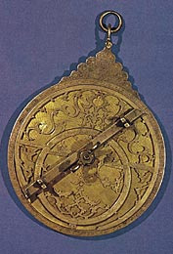

**The Astrolabe**: One of the most important scientific instruments developed by Muslims which was also used widely in the West until modern times.

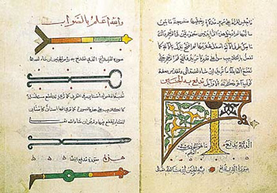

Muslim physicians paid much attention to surgery and developed many surgical instruments as seen in this old manuscript.